land only one, made to Joseph Gauntlett, was adjacent to the homestead (located at 103-4 on fig. 5.6). Of the others, Jane Day, John Clargo, Richard Bartholomew, Thomas Phillips, and William Phillips do not appear to have owned a cottage or homestead in the village. Bernard Ballard (plots 100-02), Martha Ballard (plots 96-7), John Ballard (plots 112-3), Bernard and Richard Orpwood (plots 94-5), John Goodwin (plot 114), William Forster (plot 105) were all given land near the village but not contiguous with their homesteads. Five others in Ardington were allocated two parcels; three were in three blocks, three in four, and one in five. William Wiseman Clarke was allocated almost 553 acres in sixteen blocks and John Pollexfen Bastard, 410 acres in seventeen. The land allocated to the larger landowners tended to be more dispersed around the parish and, because it was generally assumed that the larger proprietors would have sufficient capital to improve the downland on enclosure, often included most of the downland. At Ardington, in spite of the clause in the 1801 General Inclosure Act directing the commissioners to allocate to small holders before that of the larger landowners, the awards to Bastard and Clarke appear to have taken precedence. However, even for the large landowners, the inconvenience caused by the lack of consolidation of lands along with the high cost of enclosure could cause serious problems. These factors were at least in part responsible for the sale of the estate of the Clarke family in Ardington in 1826 after it had been in the family for four centuries.
Table 5.1 Farms identified in the 1841 Census of Population
Village | Farms in 1841
 | In the village | Outside the village
Ardington | 8 | Lockhouse, Hill, Betterton, Wick Farms
West Lockinge | 1 | 0
Grove | 6 | Barwell, Grove Wick, Grove Farms
Wantage | Manor Farm plus 9 others | Lattin Down, White House, Furzwick, Red House, Mead Farms
East Challow | 4 | South Woodhill, North Woodhill, Marsh, Hill Farms
Letcombe Regis | Moat House Farm plus 9 others | Bowers Farm
West Challow | Coppice Lease Farm plus 6 others | Milsum, Petwick, Farms
East Lockinge | 2 | Pinmarsh, West Ginge Farm
Charlton | 5 | Windsor, Tullwick Farms
Notes: 1. Italicised farms were established before the parliamentary enclosure award
2. East Locking and Charlton were not fully enclosed at the time of the census
3. It has not been possible to find an exact location for Milsum Farm
Source: Census of Population, 1841
The general perception that enclosure caused the disintegration of the village as farming families moved out of the centre onto the newly created, enclosed farms is, at least in the Wantage area, only justified over the very long term. Many of the isolated farms in the area were the result of earlier enclosures. The house at Ardington Wick, for example, was built in 1687 and area around it was enclosed for paddocks and pasture along with land in the common field. People were used to travelling from the village to their fields and, for the most part, continued to do so for several generations. For a farmer holding land on the downs, daily travel was not practical and certainly not efficient but enclosure was expensive. The relocation in the Wantage area generally took at least one generation and often longer. Neither farmers nor landowners had spare capital to build the dwellings, barns, outhouses and the like needed for a new farm particularly when there was a perfectly good dwelling in the village. In part this was due to the lack of consolidation of land into a single working unit.

The commissioners could also help to maintain the integrity of the village by locating land as close to the homestead as possible. However, over several generations there was a gradual relocation of the farms. As a general rule in England in the early nineteenth century, farmers were tenants rather than owners of the land they farmed. Enclosure dealt with ownership. For this reason the enclosure award offers limited insight into the formation and location of farms. From 1841 the census of population provides sufficient detail to identify farmers and the approximate location of their farms (see Table 5.1). This census taken between twenty and thirty years after the awards in West Challow, Letcombe Regis and East Challow, Wantage and Grove, and Ardington, shows little progress in the creation on the idealised compact farm with the farmhouse, barns, stables, and other buildings at its centre. Of the seventy-six farms identified in the parishes, 53, including Coppice Lease Farm, Manor Farm, and Moat House Farm, were still in the villages. At least nineteen of those farms located away from the villages were established before parliamentary enclosure, leaving only a possible four of a total of 76 farms noted in the census that may have been built in the decades after enclosure. Ten years later in 1851 another three farms – Sandpit at East Challow, Castle Road Farm at Letcombe Regis, and Angell Down Farm at Wantage were added to the list of farms located away from the village after enclosure while the total number of farms had fallen by six. This trend continued. By 1861, after the enclosure of East Lockinge, there had been considerable consolidation of land into fewer farms. At the time of this census only 60 farms, including Lockhouse Farm that was uninhabited, were included on the enumeration. Two additional farms, Warborough Farm at Wantage and Neville’s Farm, an early enclosure farm in West Lockinge occupied by an agricultural labourer were located outside the village. By 1881 67 farms were identified. The number in Wantage had fallen by a quarter with three new farms, Chainhill, Ham, and Stockham enumerated as farms outside the town. At Ardington seven farms were identified in 1861 and only three in 1881. Ardington Wick was not listed (though it remained a farm), nor was the previously unoccupied Lockhouse Farm. The number in Grove rose from seven to thirteen, at Letcombe Regis from nine to fourteen, and at East Lockinge from three to five. At Grove the farms were more scattered along the roads leading out of the village centre but were still close to the village. Bithams Farm in East Lockinge was built on the old open-field arable land. Thus, while the majority of farms remained in the villages, several of these were new farms located on the former open fields and downs. The 1881 census demonstrates the very gradual relocation of farms in the areas of the early nineteenth century enclosures. However, as shown on the 1883 Six Inch Ordnance Survey Map in the village of Charlton where enclosure had occurred only fifteen years earlier, there was still a cluster of farms, including one of 1100 acres, in the village (see fig.5.7).

Once land had be divided and enclosed, the farmer had to decide for the first time what he was going to grow on his allocation. Some farmers saw no need to change and continued to farm using the cropping calendar they had always followed. However, the situation had changed. The arable and meadow were no longer thrown open to the village flock and herd - managed in the common fields by a shepherd or herdsman employed by the village - to provide manure for the land. The farmer of enclosed land had to feed sufficient stock to manure his land and their care rested solely in his hands. This need alone may have been enough to encourage farmers to try the ‘new’ rotations involving regular courses of roots and clover/grass leys. Even on a small plot, rotational agriculture was essential to maintain fertility and prevent the build-up of disease, weeds, and pests. The new rotation had the additional benefit of providing a good supply of year round animal feed from the turnips and grasses, while still producing crops of wheat and barley for marketing. The rotation could be adjusted to meet the demands of market, to suit the quality of the land and the needs of the animals. If the land were very fertile, as much was in the Wantage area, a rotation very much like the famous Norfolk Four Course On poorer land the years in grass and clover could easily be extended to help the land maintain fertility. The new rotation was ideal for much of the enclosed arable. It was flexible. It maintained the fertility of the soil. It provided feed for livestock. At Ardington for example, by 1841 when the tithe report was written, the land of five qualities had been identified – the downs, the partly chalky and gravely loams, good open clay loam, strong tenacious clay, and rich clay loam and put to different uses. The downs were mostly pastured by sheep but where arable it was suited to being cropped in a five course of wheat, turnips, barley, then two years of ley. The chalky loam was best managed in a six course with four years of wheat, barley, or oats and one year each of turnips and clover ley. The good clay loam was farmed in an eight course of wheat, turnips or vetches, barley or oats, clover ley, wheat, fallow, barley or oats, and finally another clover ley. The tenacious clay arable was too heavy – i.e. too hard to work into a good consistency, for roots like turnips, so was fallowed when necessary and the rest of the time mostly sown to corn. The rich clay loam was almost entirely in grass. The impact on the landscape of these changes was immense. The greater variation in cropping routines after the entire parish was enclosed created a patchwork pattern of colours and textures in the landscape that was very different from the more uniform cropping of the open field system.
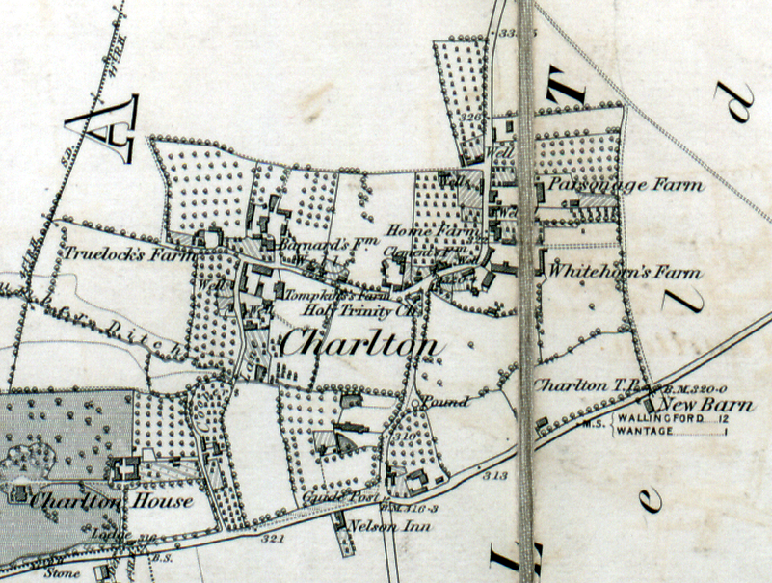
Like much of the clay soils throughout northwest Berkshire, much of the northern area of the four parishes was unsuited to arable husbandry. The heavy clay, and anyone who has tried to work this soil in their garden will understand the concept of a heavy soil, could only be worked during dry weather so was best suited to planting down to permanent pasture. Some was even unsuited to be used as pasture. In a report assessing the parish of Ardington for tithe commutation, the inspector commented:
Fig. 5.7 While the relocation of farms associated with enclosure did occur, it often took several generations. This map of Charlton made fifteen years after enclosure shows a continuing concentration of the farms in the village.
Source: Six Inch Ordnance Survey Map, 1883
meadow land in Ardington is exceedingly wet and low and totally unfit for stock in the winter – some of these meadows are very productive – the larger portion of them are mown every year and the Hay sold. They are scarcely accessible in the winter

Because it was difficult to manage as arable, much of the very heavy clay land had already been converted to grassland after earlier enclosure. Of the remaining was much converted at the time of the award and has remained in grass ever since. There is physical evidence of this long-standing conversion to grassland in some of the fields in the northern part of the area. Because heavy clay land was difficult to drain, ploughing was done in such a manner so to create a corrugated pattern of raised ridges on which the crops were planted and depressions, or furrows, that would help the water drain off the field. When land was converted from tillage to grass, the ridge and

BRO, Q/RDC 89A
Havinden, 1999, 45; 48
BRO D/ECw T4
Hoskins, 1957a, 99-100; Turner, 1984, 159
Censuses of Population 1841- 1881
Using the census for the location of farms is not an exact method. Some farms were occupied by agricultural labourers and farm bailiffs. Where these were noted as farms on the census they were included in the list as were farmers living in the villages.
National Archives, Kew IR 18/13096
National Archives, Kew IR 18/13096

